FEDERAL UNIVERSITY OF TECHNOLOGY OWERRI (FUTO)
P.M.B. 1526 OWERRI, IMO STATE.
A TECHNICAL REPORT ON THE STUDENT INDUSTRIAL WORK EXPERIENCE SCHEME (SIWES 400L)

DONE AT

FLASH-CLOUD EDUCATIONAL SYSTEMS
AREA N, ZONE 5, WORLD BANK, IMO STATE.
BY
ABIAHU ONISMUS CHUKWUEBUKA (20191175195)
SUBMITTED TO
THE DEPARTMENT OF STATISTICS, SCHOOL OF PHYSICAL SCIENCES.
IN PARTIAL FULFILMENT OF THE REQUIREMENTS FOR THE AWARD OF BACHELOR OF TECHNOLOGY (BTECH) DEGREE IN STATISTICS.

JUNE, 2024

DECLARATION
This is to declare that I ABIAHU ONISMUS CHUKWUEBUKA with the registration number 20191175195 was the one that did this work from the beginning to the end.

Sign Date
………………………. .………………………
Abiahu Onismus Chukwuebuka

DEDICATION
This SIWES industrial report is dedicated to God almighty and to my parent, MR. AND MRS. LAMBERT ABIAHU, for their support and encouragement throughout the SIWES program and also to our industrial based supervisor.

ACKNOWLEGEMENT
As it is said, in everything God first and he came first for me, so I'm grateful to God for providing me with the grace and fortitude to finish my IT successfully. Also, I would like to thank the following people, without whom I would not have been able to perform and scale through in my IT period. The Head of Department, Statistics; DR. C.J. OGBONNA for his unwavering efforts in making sure that all activities concerning the department are successfully carried out. My lovely class adviser and the assistant, 2019 Set; PROF (MRS). N. P. OLUWEZI and MRS. DURU IHEOMA for their guidance and advice. PROF. NWOGU; for his kind encouragement. Dr UGWUANYIM; for his instructions and guidance. My sweet mother; EVAN.(MRS) EMELDA ABIAHU for her words of encouragement and financial support. My brother; MR PAUL ABIAHU for his care and support during my IT. My eldest sister and husband; MR and MRS NELSON CHUKWUEMEKA for providing a place to stay while doing my IT. My Academic Mentor; MR and MRS DESMOND CHEKWUBE for his guidance and helping in arranging my questionnaire and analysis. To my Course Rep; MR NWAOKAFOR CHIMAOBI for helping me financially during the IT. Still doesn’t forget to thank all that helped either in prayers, financially, advice that I could not mention here. God bless and keep you all.

ABSTRACT
This report shows the work done during my industrial training at Flash-cloud educational systems Area N, Zone 5, World Bank Owerri Imo State. I was able to gain knowledge in AI and Robotics, Data Analysis (Machine learning) and Computer Vision. The increasing relevance of Artificial Intelligence (AI) and Robotics in Statistics has transformed the field, offering innovative solutions to complex problems. Again the increasing rate of data has brought concern of how human can be able to manage them. As a result of Technology and how large and complicating data are, the report is to explore the significance of AI and Robotics in Statistics. Also the report investigates the perceptions and experiences of Statistics practitioners regarding the adoption and impact of AI and Robotics in their work. The study collected data from 90 people; young and old, experienced and non-experienced of the field of Statistics, AI and Robotics and others, levels of familiarity and usage through a structured questionnaire. The report also contains quantitative and qualitative data that are carefully collected which were analyzed using statistical software; EXCEL and SPSS. Decisions and conclusions are made from the results gotten in the analysis of this report. Experience gained; problems faced were all stated in this work. The method of analysis is by Likert Scale Scoring or Weighted Average.

TABLE OF CONTENTS PAGE

DECLARATION i
DEDICATION ii
ACKNOWLEGEMENT iii
ABSTRACT iv
TABLE OF CONTENTS v
CHAPTER ONE 1
INTRODUCTION AND PLACEMENT OVERVIEW 1
1.1 Introduction to This Report 1
1.1.1 What Is Data? 1
1.1.2 How Does Machines Get their Own Information? 1
1.1.3 Why Do We Need Data Analysis? 1
1.1.4 The Ideas of this Report 2
1.2 PLACEMENT OVERVIEW 2
1.2.1 About Flash-Cloud World Bank 2
1.2.2 The Objectives 4
1.2.3 Services Rendered 4
1.2.4 Teaching Capacity 4
CHAPTER TWO 5
OVERVIEW OF AI AND ROBOTICS 5
2.1 Introduction to Artificial Intelligence (AI) 5
2.1.1 Branches of AI 6
2.1.2 Can Machines Learn? 6
2.1.3 Types of Machine Learning 6
2.1.4 Steps Involve in Machine Learning 6
2.2 Introduction to Robotics 7
2.2.1 What Is a Robot? 7
2.2.2 Parts of a Robot 7
2.2.3 Classification of Robots 8
2.2.4 Data Analysis 8
2.2.5 The Steps/Processes in Data Analysis 9
2.2.6 Data Strategies 9
CHAPTER THREE 10
WORK DONE/METHOD OF DATA COLLECTION AND ANALYSIS 10
3.1 Work Done During the Six Months Students Industrial Work Experience Scheme 10
3.1.1 10
3.1.2 WORK OVERVIEW 15
3.2 METHOD OF DATA ANALYSIS 16
3.2.1 Key characteristics of likert scale: 16
CHAPTER FOUR 17
DATA ANALYSIS AND RESULTS PRESENTATION 17
4.1 Data Analysis 17
4.1.2 Demographic visualization 17
4.1.3 Gender of the Respondents 17
4.1.4 Age of the Respondents 18
4.1.5 The likert scale analysis for the different questions 19
4.1.6 Discussion 20
CHAPTER FIVE 21
KNOWLEDGE GAINED AND IT’S STATISTICAL RELEVANCE 21
5.1 Knowledge Gained 21
5.1.1 Statistical Relevance 21
5.1.2 CONCLUSION 21
5.1.3 Problems Encountered 21
5.1.4 RECOMMENDATION 22
REFERENCES 23
APPENDIX. 24

CHAPTER ONE

INTRODUCTION AND PLACEMENT OVERVIEW

1.1 Introduction to This Report
The field of Statistics has undergone significant transformations in recent years, driven by the rapid advancement of AI and Robotics. These technologies have revolutionized numerous disciplines, and Statistics is no exception. AI and Robotics have the potential to enhance Statistical analysis, improve data interpretation, and automate complex processes. However, the adoption and implementation of these technologies in Statistics remain uneven, with varying levels of understanding and acceptance among practitioners. This report unveils a little introduction to AI and Robotics, a little explanation of how machines learn if actually the do and the significance of it in Statistics. As a result of so many features in technology, man has due to curiosity invented machines that can inhibits and replicate human intelligence .These machines do this by collecting and studying a dataset over time. This now makes meaning afterwards.

1.1.1 What Is Data?
Data is unprocessed information. It can also be seen as a raw information i.e it is still meaningless. Data can be collected in two (2) sources; primary and secondary sources. In primary source, data is collected by the same person who is to harness it. But when data is collected and used by another person, it is said to be secondary source.

1.1.2 How Does Machines Get their Own Information?
I know that the question now is: how do machines get their own data? Do the generate data by themselves? The idea behind this is that every machine which exhibit human intelligence is programmed. Program is a given instruction for an activity to happen. This is the reason why most scholars go in acquiring the skills of a front-end developer, back end developer, machine learning etc. with this, we now understand why this machines behave the way they do because they were programmed.

1.1.3 Why Do We Need Data Analysis?
Data is short hand for “information,” and whether you are collecting, reviewing, and/or analyzing data, this process has always been part of Head Start program operations. Children’s enrollment into the program requires many pieces of information. The provision of health and dental services includes information from screening and any follow-up services that are provided. All areas of a Head Start program – content and management – involve the collection and use of substantial amounts of information. For Master of Science in Health (MSHS) programs, the use of data becomes even more crucial, as essential information must be managed within relatively short program seasons. As new requirements have been added, and new program initiatives launched, programs are increasingly expected to use data in meaningful ways.
Finally, if the PRISM process will “focus on the collection, reporting, and analysis of data,” programs are well advised to develop their expertise in working with data.
Lastly, recent Head Start sources support the need for a better understanding of data analysis in our work.

1.1.4 The Ideas of this Report
It is obvious that data is everywhere. And the data that are generated in the field of work are so large and complicated that experts find it hard to explain the meanings behind these data. Data were carefully collected and analyses were made in this report to help readers and students to make valuable conclusion on the Significance of AI and Robotics in Statistics.

1.2 PLACEMENT OVERVIEW

1.2.1 About Flash-Cloud World Bank
Flash-cloud as an educational system, that acquit scholars with knowledge of AI and Robotics started in Lagos State. Where it has been acquitting students with the necessary knowledge in the specialization within it’s areas of specialization chosen by the student. It was doing well as scholars are benefitting from it greatly. It came to a time when the MD (Eng. Emmanuel) thought it wise to bring it home base. People outside the home has been enjoying the knowledge, so it’s time that the scholars at home has to fetch from the well too.
Firstly, he brought it at the Federal University of Technology Owerri (FUTO), where he started grooming students who had interest in gaining the knowledge. As time goes, Eng. Emmanuel got a permanent location at Area N, Zone 5, World Bank. He then took the organization to the location where he now has his structure and academic setting where students can comfortably acquire knowledge. At 2024 when my IT took place, Flash-cloud has stayed 2years it came to World Bank
The institute do not have departments rather than it’s movement towards transmission of knowledge. It only has three (3) levels; The Managing Director in the person of Eng. Emmanuel, the instructor Mr. Isaac Humble: who is teaching and seeing that students are groomed, and the students. There is also a front office were registration takes place. In other to develop these students, the institute is equipped with the necessary instrument with which the students can learn properly and the atmosphere is conducive. There is a Ukit Edu. Board for Robotics, a computer, a projector, a printer, a generator etc.
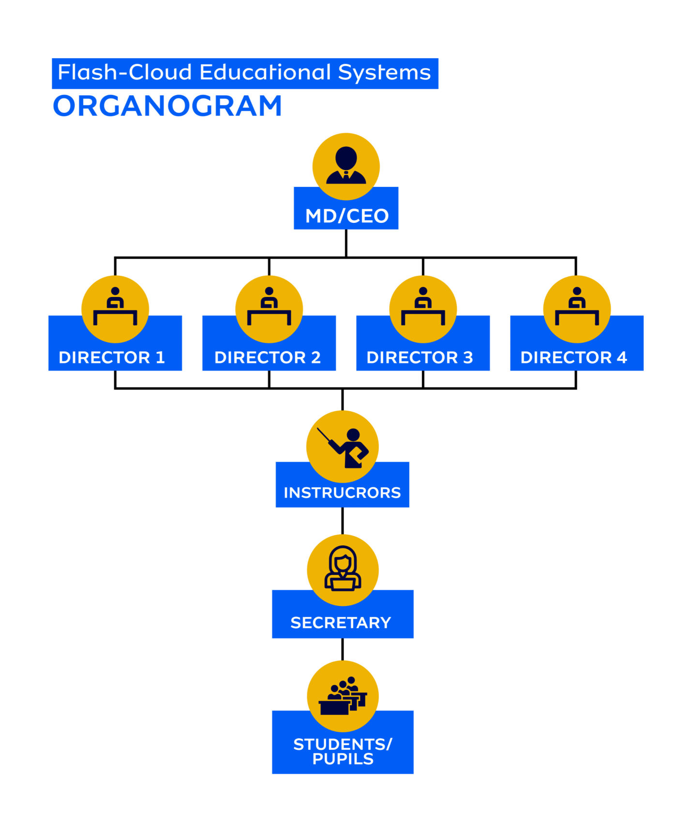
Figure 1.1 Flash-cloud Organogram

1.2.2 The Objectives
Flash-cloud Educational Systems has a motive of enlightening students who are interested and willing to explore skills that are selling in today’s world. The achieve this by;
- Allocating a quality time to every course undertaking by scholars
- Making sure that the instructor is one that is good at what he is doing
- Creating a good relationship between scholars and the management
- Ensuring a conducive environment for learning
- Making the fee very affordable
- Issuing of certificates to their scholars

1.2.3 Services Rendered
Indeed, Flash-cloud Edu. Does not offer or teach any and everything. It has areas of specialization which are;
- Artificial intelligence (AI)
- Machine learning
- Robotics and applications such as; Image Analysis, Smart Factory, 3D Design and printing, Collaborative Robots, Internet of Things (IOT), Remote Patient Monitoring, Nursing Assistance.
- Web development
- Graphics design
- Data analysis

1.2.4 Teaching Capacity
As we have understood, Flash-cloud has a hub where it accepts scholars who have the capability to be coming to learn either on a daily, weekly or even weekend basis depending on the agreement. It accepts students of different category. There are children, teenagers, adults, IT students etc who are learning in different fields.
Also, Flash-cloud moves from one secondary schools to another in teaching AI and Robotics to students. She handles up to four (4) or five (5) schools each term.

CHAPTER TWO

OVERVIEW OF AI AND ROBOTICS

2.1 Introduction to Artificial Intelligence (AI)
The emanation of AI started thousand years ago with scientists and philosophers. In early 1940’s and 1950’s, some group of persons, organizations started asking the question, can machine think? So many philosophers, scientist, scholars have been able to give their own explanation to the question. Alanturing in his publication computer machinery intelligence gave his own explanation of can machine think? He wrote that if a machine can engage in a conversation with a human successfully without being detected as a machine, it has demonstrated human intelligence.
Table 2.1 Alanturing Explanation
A | B | C
1 | 2 | 3

Ideally, Alanturing explanation was that if the alphabets A,B,C in table 2.1 above is to be humans and unfortunately, one of them was a machine. Again, if a human is introduced to 1 in table 2.1 without seeing what is at the other side and he engaged in a conversation successfully. Then he moves to 2 and succeed, same in 3 without detecting that one of his conversations was with a machine. Hence the machine has demonstrated human intelligence which he called a thinking machine or imitation game. This exercise was called the Turing test. The Turing test was a deceptively simple way of determining whether a machine can demonstrate human intelligence. Experts use the Turing test to measure computer intelligence.
Another great scholar called JOHN McCARTHY (the father of AI) came up to modify the Turing test. He said that instead of calling it a thinking machine, let’s call it artificial intelligence. He then defines AI as a branch of science and engineering that deals with the creation of intelligent machines i.e machines that can exhibits complex human characters. The complex human characters are;
- Reasoning
- Planning
- Learning
- Listening
- Speaking and understanding spoken languages
- Giving responses etc.

2.1.1 Branches of AI
- NATURAL language processing (NLP)/Natural language understanding (NLU)
- Machine learning (ML)
- Fuzzy logic
- Expert systems
- Neural networks
- Robotics

2.1.2 Can Machines Learn?
These became the question of so many scholars. The point is that they can learn to observe data and draw out hidden and obvious patterns. Human can also help machines to learn i.e when it can’t understand the source code. Hence machine learning is a process through which machines (especially computer programs) learn to observe hidden and obvious patterns in a set of data. Data is our main focus here. Why we need to analyze data is because it is an unorganized one. Data can be gotten primarily or secondarily.

2.1.3 Types of Machine Learning
- Supervised machine learning
- Unsupervised machine learning
- Reinforcement machine learning

2.1.4 Steps Involve in Machine Learning
- Problem identification
- Data collection
- Data preparation
- Model choosing
- Model training
- Evaluation of the model
- Model tuning or parameter tuning
- Making prediction

2.2 Introduction to Robotics
By Isaac Asimov, he defined robotics as a branch of computer science and engineering that deals with the creation of robots. In 1920, karl carpek in his book Rossum’s Universal Robot ( RUR) explained a kind of structures that were doing work in favor of others. He was confused of what to call them when his brother joseph carpek now called them Robot.
The word robot is from a Czech Slavic word “Robota” which means slave. Now the fear was that machine will take over the world. Hence Isaac Asimov, a biochemist wrote about how a robot and human can coexist. He then postulates the three (3) rules known as the laws of robotics which are;
- A robot must protect man and not through inaction cause harm to man
- A robot must obey every command giving to it by man except it goes against the first law
- A robot must protect its own existence except in so doing goes against the first and the second law
The laws were modified to bring out the zeroth law which hammers that a robot must protect humanity.
So many scholars have argued that these laws are not applicable. Reason is because science has now been weaponized. Now we have missiles, drones that kills human etc. Then the laws are not applicable in real life. Isaac Asimov was the first to use robotics while karl carpek was the first to mention robot.

2.2.1 What Is a Robot?
A robot is an electromechanical device that is designed, built, programmed and reprogrammable to carry out a given task. When it is built without a proper instruction, it is a toy.

2.2.2 Parts of a Robot
There are basically four (4) parts of a robot which are essential. They are;
- The controllers; e.g. is the Arduino mega and the UB Tech explore board. The controllers do three works;
- It stores information
- Processes information
- It coordinates other affaires
- The sensors e.g. are the infra-red sensor, ultrasonic sensor etc. the sensors take information from the environment.
- The actuators e.g. are the servo motors, the dc motors etc. they perform actions.
- The connectors e.g. are the wires, the pegs etc. they are used to make connections.

2.2.3 Classification of Robots
- Classification based on features which we have;
- Autonomous mobile vehicle (AMV)
- Automated guided vehicle (AGV)
- Humanoids
- Selective compliance automated robots (SCARA) or articulated robots
- Collaborative robots (COBOTS)
- Classification based on habitat which we have;
- Terrestrial robots
- Unmanned aerial vehicle
- Underwater vehicle (UV)
- Classification base on application which we have;
- Service robots
- Industrial robots
- Classification base on degree freedom which we have;
- Cartesian plane
- Scara
- Exoskeletal robots.

2.2.4 Data Analysis
Data analysis includes ways of working with information (data) to support the work, goals and plans of your program. It is the act of manipulating data to bring out hidden and obvious meaning in it.

2.2.5 The Steps/Processes in Data Analysis
- Purpose or problem identification
- Questions
- Data collection
- Manipulation of data collected
- Interpretation/identification of the findings
- Writing, reporting, dissemination and evaluation.

2.2.6 Data Strategies
There are a variety of strategies for quantitative and qualitative analyses, many of which go well beyond the scope of this report. Different strategies provide data analysts with an organized approach to working with data; they enable the analyst to create a “logical sequence” for the use of different procedures. In the listing below, we offer four examples of strategies for quantitative analysis that you may consider as you work with and develop your skills in data analysis as well as reasons why you may consider using the strategy.
Strategy 1: Data Visualization; meaning Creating a visual “picture” or graphic display of the data.
Reason(s): a way to begin the analysis process; or as an aid to the reporting/ presentation of findings.
Strategy 2: Exploratory Analyses means Looking at data to identify or describe “what’s going on”? Creating an initial starting point (baseline) for future analysis.
Reason(s): Like you have a choice?
Strategy 3: Trend Analysis means Looking at data collected at different periods of time.
Reason(s): to identify and interpret (and, potentially, estimate) change.
Strategy 4: Estimation meaning Using actual data values to predict a future value.
Reason(s): to combat boredom after you have mastered all the previous strategies.

CHAPTER THREE

WORK DONE/METHOD OF DATA COLLECTION AND ANALYSIS

3.1 Work Done During the Six Months Students Industrial Work Experience Scheme (SIWES)

During my industrial training, I was able to learn under and work with my teacher (supervisor); MR EBUEHI ISAAC HUMBLE. From whom I gained valuable experience and insights into the field of statistics applied to artificial intelligence. All through my stay as an IT student there, my primary responsibility was to learn, follow my instructor to secondary schools to teach, collect, record, analyze and interpret student’s data. I was able to work with my teacher, colleagues and community to investigate the SIGNIFICANCE OF AI AND ROBOTICS IN STATISTICS.

3.1.1 Method of Data Collection
In other to ensure accurate and unbiased decision, I designed appropriate questionnaire as my mode of valuable data collection. A questionnaire is a set of printed, written or online questions with a choice of answers, designed for the purpose of a statistical study. That is, it is a set of questions and answers. Here I use a Google form questionnaire which consists of 8 questions which includes Demographic data (age, gender, department etc) and Multiple-choice question on AI and Robotics knowledge, Statistics knowledge etc. In other to reach out to different level of people across the world and to get a quality data, different platforms were use to do so. The three main platforms are;
- Community: community here stands for the coming together of AI and ROBOTICS students. These I achieved by going to secondary schools to teach with my supervisor. And in so doing, forming students who are passionate about the course and the applications in real life. Hence the questionnaire was administered to them to aid their views.
- Social Media: it is not doubted that social media is a community of its own, were a lot of people from different field with different ideals meet. Hence, I was able to navigate two main social media; Facebook, were I met so many scholars in groups, on my page and on my direct message to administer the questionnaire. Another is the WhatsApp, were I met them in groups, my direct message and on my statues to administer the questionnaire.

TABLE 3.1a Sturdy Data
S/N | DISCIPLINE | GENDER | AGE | Experience (Statistics) | Experience (Robotics) | Robotics solves statistics? | Robotics is an improved method for statistics? | Robotics is an easy method for statistics?
1 | Statistics | Male | 21 to 30 | < 1yr | < 1yr | SA | Agree | SA
2 | Others | Male | 21 to 30 | 3 to 4 years | 3 to 4 years | SA | SA | Agree
3 | Statistics | Male | 21 to 30 | < 1yr | < 1yr | SA | SA | SA
4 | Others | Female | 21 to 30 | < 1yr | < 1yr | Agree | Agree | Agree
5 | Statistics | Female | 21 to 30 | 1 to 2 years | 1 to 2 years | Agree | Agree | Agree
6 | AI and Robotics | Female | 21 to 30 | 1 to 2 years | 1 to 2 years | Agree | Agree | Agree
7 | Statistics | Female | 21 to 30 | < 1yr | < 1yr | Agree | Agree | Agree
8 | AI and Robotics | Male | 21 to 30 | < 1yr | < 1yr | Disagree | Disagree | Disagree
9 | AI and Robotics | Female | 21 to 30 | > 4yr | 3 to 4 years | SA | SA | Agree
10 | Others | Female | Below 20 | < 1yr | 1 to 2 years | SA | Agree | Neutral
11 | Others | Male | Above 50 | 1 to 2 years | < 1yr | Agree | Agree | Agree
12 | Others | Male | 21 to 30 | < 1yr | < 1yr | Agree | Agree | Agree
13 | Statistics | Male | 21 to 30 | 1 to 2 years | 1 to 2 years | SA | SA | Agree
14 | Others | Female | 21 to 30 | 1 to 2 years | 1 to 2 years | SA | Agree | Agree
15 | AI and Robotics | Male | 21 to 30 | 1 to 2 years | < 1yr | Agree | Agree | Disagree
16 | Others | Male | 21 to 30 | < 1yr | < 1yr | Agree | Agree | Agree
17 | Others | Male | 21 to 30 | < 1yr | < 1yr | SD | Disagree | Disagree
18 | Statistics | Male | 21 to 30 | > 4yr | 3 to 4 years | SA | SA | Agree
19 | Others | Female | 21 to 30 | < 1yr | < 1yr | Agree | Agree | Neutral
20 | Others | Female | 21 to 30 | < 1yr | < 1yr | Agree | Agree | Neutral
21 | Statistics | Male | 21 to 30 | 3 to 4 years | < 1yr | Agree | Agree | Agree
22 | Others | Female | 21 to 30 | < 1yr | < 1yr | Neutral | Neutral | Neutral

TABLE 3.1b Study Data Contd.
23 | Statistics | Male | 21 to 30 | > 4yr | > 4yr | SA | Agree | Neutral
24 | Statistics | Male | 21 to 30 | 1 to 2 years | < 1yr | Agree | Agree | Agree
25 | AI and Robotics | Male | 21 to 30 | > 4yr | < 1yr | Agree | SA | Disagree
26 | Statistics | Female | 21 to 30 | > 4yr | < 1yr | SA | SA | SA
27 | AI and Robotics | Female | 21 to 30 | > 4yr | < 1yr | Agree | Agree | Agree
28 | Statistics | Male | 21 to 30 | < 1yr | < 1yr | SA | SA | SA
29 | Statistics | Male | 31 to 40 | > 4yr | > 4yr | SA | Neutral | SA
30 | AI and Robotics | Male | 31 to 40 | > 4yr | > 4yr | SA | Neutral | SA
31 | AI and Robotics | Male | 21 to 30 | < 1yr | < 1yr | SA | SA | Neutral
32 | AI and Robotics | Female | Below 20 | 1 to 2 years | > 4yr | SA | Agree | Neutral
33 | Others | Male | 21 to 30 | 3 to 4 years | < 1yr | Agree | Agree | Agree
34 | AI and Robotics | Male | 31 to 40 | < 1yr | 3 to 4 years | Agree | SA | Disagree
35 | AI and Robotics | Female | 21 to 30 | < 1yr | > 4yr | SA | SA | SA
36 | AI and Robotics | Female | 21 to 30 | 1 to 2 years | 1 to 2 years | Agree | Agree | Agree
37 | Statistics | Male | 31 to 40 | > 4yr | 3 to 4 years | SA | Agree | Disagree
38 | Others | Male | 21 to 30 | 3 to 4 years | 1 to 2 years | Agree | Agree | Agree
39 | Statistics | Male | 41 to 50 | > 4yr | < 1yr | Agree | Neutral | Disagree
40 | AI and Robotics | Female | Below 20 | > 4yr | > 4yr | SA | Agree | Neutral
41 | Others | Female | 31 to 40 | < 1yr | 1 to 2 years | Agree | Agree | Agree
42 | AI and Robotics | Female | 41 to 50 | < 1yr | > 4yr | Agree | SA | Disagree
43 | AI and Robotics | Female | 21 to 30 | < 1yr | > 4yr | SA | SA | SA
44 | Others | Male | 21 to 30 | 3 to 4 years | < 1yr | SA | Agree | Neutral
45 | Statistics | Male | 21 to 30 | 1 to 2 years | < 1yr | Agree | Agree | Agree
46 | AI and Robotics | Male | 21 to 30 | > 4yr | < 1yr | Agree | SA | Disagree
47 | AI and Robotics | Female | 21 to 30 | > 4yr | < 1yr | SA | SA | SA
48 | Statistics | Female | 21 to 30 | > 4yr | < 1yr | Agree | Agree | Agree
49 | Others | Male | 41 to 50 | < 1yr | 1 to 2 years | SA | Agree | Neutral

TABLE 3.1c Study Data Contd.
50 | Others | Female | Above 50 | 1 to 2 years | < 1yr | Agree | Agree | Agree
51 | Others | Male | 21 to 30 | 1 to 2 years | < 1yr | Agree | SA | Disagree
52 | Others | Female | 31 to 40 | < 1yr | 1 to 2 years | SA | SA | SA
53 | Statistics | Female | 21 to 30 | > 4yr | < 1yr | Agree | Agree | Agree
54 | Statistics | Male | 21 to 30 | > 4yr | > 4yr | SA | Agree | Neutral
55 | Others | Male | 21 to 30 | 1 to 2 years | < 1yr | Agree | Agree | Agree
56 | Statistics | Male | 21 to 30 | > 4yr | < 1yr | Agree | SA | Disagree
57 | AI and Robotics | Female | 21 to 30 | > 4yr | < 1yr | SA | SA | SA
58 | Statistics | Female | 21 to 30 | > 4yr | < 1yr | Agree | Agree | Agree
59 | AI and Robotics | Male | 21 to 30 | > 4yr | > 4yr | Agree | SA | Disagree
60 | AI and Robotics | Female | 21 to 30 | < 1yr | > 4yr | SA | SA | SA
61 | AI and Robotics | Female | 21 to 30 | < 1yr | > 4yr | Agree | Agree | Agree
62 | Statistics | Male | 21 to 30 | > 4yr | > 4yr | SA | Agree | Neutral
63 | Statistics | Male | 21 to 30 | 1 to 2 years | < 1yr | Agree | Agree | Agree
64 | AI and Robotics | Male | 21 to 30 | > 4yr | < 1yr | Agree | SA | Disagree
65 | Statistics | Female | 21 to 30 | < 1yr | < 1yr | SA | Agree | Neutral
66 | Statistics | Female | 21 to 30 | > 4yr | < 1yr | Agree | Agree | Agree
67 | Others | Male | 31 to 40 | < 1yr | 1 to 2 years | SA | Agree | Agree
68 | Others | Male | 21 to 30 | > 4yr | 1 to 2 years | Agree | Agree | Agree
69 | Others | Male | 31 to 40 | 3 to 4 years | 1 to 2 years | Agree | Agree | Disagree
70 | Statistics | Male | 21 to 30 | 3 to 4 years | 3 to 4 years | SA | SA | Neutral
71 | Others | Male | 31 to 40 | 1 to 2 years | 1 to 2 years | SA | Agree | Agree
72 | AI and Robotics | Male | 31 to 40 | 1 to 2 years | 1 to 2 years | SA | SA | Disagree
73 | Others | Male | 31 to 40 | > 4yr | > 4yr | Agree | Agree | Agree
74 | Others | Female | 21 to 30 | 1 to 2 years | 1 to 2 years | Agree | Agree | Agree
75 | AI and Robotics | Female | 21 to 30 | > 4yr | > 4yr | SA | Agree | Neutral
76 | AI and Robotics | Female | 21 to 30 | < 1yr | 1 to 2 years | Agree | Agree | Agree

TABLE 3.1d Study Data Contd.
77 | Others | Male | 21 to 30 | 1 to 2 years | > 4yr | Agree | SA | Disagree
78 | AI and Robotics | Female | 21 to 30 | < 1yr | 3 to 4 years | SA | SA | SA
79 | AI and Robotics | Female | 21 to 30 | < 1yr | > 4yr | Agree | Agree | Agree
80 | Statistics | Male | 21 to 30 | 3 to 4 years | < 1yr | SA | SA | SA
81 | Statistics | Male | 21 to 30 | 1 to 2 years | < 1yr | Neutral | Neutral | Neutral
82 | AI and Robotics | Male | Below 20 | < 1yr | < 1yr | Agree | Agree | Agree
83 | Statistics | Male | 21 to 30 | 1 to 2 years | < 1yr | SA | SA | Agree
84 | Others | Female | 31 to 40 | 1 to 2 years | < 1yr | SA | Agree | Neutral
85 | Others | Male | Above 50 | 3 to 4 years | 1 to 2 years | Agree | Agree | Agree
86 | AI and Robotics | Female | 21 to 30 | < 1yr | < 1yr | SA | SA | SA
87 | Others | Male | Below 20 | < 1yr | < 1yr | Neutral | Disagree | Disagree
88 | Statistics | Male | 31 to 40 | > 4yr | < 1yr | SA | SA | SA
89 | Statistics | Male | 21 to 30 | 1 to 2 years | < 1yr | SA | SA | SA
90 | AI and Robotics | Male | 21 to 30 | 1 to 2 years | < 1yr | SA | SA | SA

3.1.2 WORK OVERVIEW
Teaching: one of the essential parts of this investigation is to make sure that the respondents understood what are AI and Robotics and Statistics. So, in my teachings and discussions with them, I was able to make this clear to them so as to obtain an unbiased response.
Data Collection: One of the essential tasks in any statistical analysis is data collection. I was responsible in collecting the data through questionnaire from the platforms. I also was collecting data in other aspects in the institution; e.g is the numerical strength of students in a class, the scores of students in assessments etc.
Data Cleaning and Processing: Before conducting any statistical analysis, it's crucial to ensure the data is accurate and clean. I worked on cleaning and preprocessing the data, dealing with missing values, outliers, and inconsistencies to prepare it for analysis.
Statistical Analysis: Using my knowledge of statistics and data analyses, I conducted various analyses on the collected data. I applied descriptive statistics to summarize and present key findings, and inferential statistics to draw conclusions and make decisions based on the sample data.
Software Utilization: Throughout the training, I used statistical software such as Excel, Jupiter, Rstudio and SPSS to perform the data analysis efficiently. These tools allowed me to handle large datasets and perform complex statistical tests.
Report Writing: As a statistics student, I understood the importance of clear and concise reporting. I prepared reports presenting the results of my analyses, to help communicate findings effectively.
Interpreting Results: I collaborated with my supervisor and colleagues to interpret the statistical results in the context of the investigation objectives, Together, we discussed the implications of the findings and how they could be applied to improve deeper understanding and collaboration of the different fields.
Indeed, it was a wonderful experience at Flash-Cloud Educational System Area N, Zone 5, World Bank Owerri Imo State.

3.2 METHOD OF DATA ANALYSIS
The method adopted in this report in analyzing the responses in table 3.1 above is the method of likert scoring or scoring by average. The weighted average method of analyzing a five-point likert scale questionnaire response is often referred to as likert scale scoring or scoring by weighted average.
In this method, each response on the likert scale is assigned a numerical value, typically ranging from 1 to 5, with 1 representing the lowest level of agreement or frequency and 5 representing the highest. These numerical values are then multiplied by weights assigned to each response option, reflecting their relative importance or frequency.
For example, if a likert question has responses ranging from “SD” (1) to “SA” (5), and the weights assigned are 1,2,3,4 and 5 respectively, the weighted average for each respondent’s answer can be calculated by multiplying their response by the corresponding weight and then summing these products. Finally the total sum is divided by the total number of responses to obtain the weighted average score for that question.
This method allows for a more nuanced analysis of likert scale data, taking into account the varying degrees of agreement or frequency indicated by responses. It can provide a more accurate representation of respondent’s opinions or behaviors than simple average scoring.

3.2.1 Key characteristics of likert scale:
- Rating scale: a series of categories (e.g., 1-5) that respondents use to rate their level of agreement or frequency.
- Verbal anchors: each category has a verbal label (e.g., “SD” to “SA”) to help respondents understand the meaning of each rating.
- Equal intervals: the intervals between each category are assumed to be equal, allowing for numerical analysis.
- Ordinal data: likert scale data is ordinal, meaning it has a numerical order or ranking, but the distances between categories are not equal.
- Used for attitudes, opinions, and beliefs: likert scales are commonly used in surveys, questionnaires, and research studies to measure people’s attitudes, opinions, and beliefs.
Note: the number of categories can vary but 5-point and 7-point scales are the most common.

CHAPTER FOUR

DATA ANALYSIS AND RESULTS PRESENTATION

4.1 Data Analysis
This chapter presents the results of analysis through the data that was collected at FLASH-CLOUD EDUCATIONAL SYSTEMS to examine the demographic characteristics of the respondents, examine the SIGNIFICNT OF AI AND ROBOTICS IN STATISTICS.

4.1.2 Demographic visualization
Frequency distribution analysis was carried out to obtain the number of respondents associated with the different variable.

4.1.3 Gender of the Respondents
The respondents were asked to indicate their gender, the table and pie chart below were used to summarize the gender differences.
Table 4.1 Gender Distribution of Respondents
Gender | Frequency | Percentage
Male | 53 | 59
Female | 37 | 41
Total | 90 | 100
he table labeled "Table 4.1 Gender Distribution of Respondents" shows the distribution of male and female respondents in a study. Here's a breakdown of the information presented in the table:

Frequency: This column represents the number of respondents for each gender.
Male: 53 respondents
Female: 37 respondents
Total: 90 respondents

Percentage: This column shows the proportion of respondents for each gender, expressed as a percentage of the total number of respondents.
Male: 59%
Female: 41%
Total: 100%

Explanation

The table indicates that out of the 90 respondents, 53 are male, making up 59% of the total respondents. In contrast, 37 respondents are female, accounting for 41% of the total. This distribution shows that there are more male respondents than female respondents in this study.

Interpretation
This demographic visualization helps in understanding the gender composition of the study sample. It can be useful for analyzing whether the study results might be influenced by the gender distribution and for ensuring that both genders are adequately represented in the analysis.

Figure 4.1 PIE CHART OF GENDER

The pie chart above shows that there were more male respondent than the female respondent in the questionnaire.

4.1.4 Age of the Respondents
The respondents were asked to indicate their age range, the table and bar chart below were used to summarize their differences.
Table 4.2 Age Distribution of the Respondents
Age Range | Frequency | Percentage
Below 20 | 5 | 5.6
21 to 30 | 66 | 73.3
31 to 40 | 13 | 14.4
41 to 50 | 3 | 3.3
Above 50 | 3 | 3.3
Total | 90 | 100.0
Here’s a detailed explanation of Tables 4.2 and 4.3 from the provided document:

Table 4.2 Age Distribution of the Respondents

This table provides information about the age distribution of the respondents who participated in the study. The table includes three columns: Age Range, Frequency, and Percentage.

Below 20:
Frequency: 5 respondents
Percentage: 5.6%

21 to 30:
Frequency: 66 respondents
Percentage: 73.3%

31 to 40:
Frequency: 13 respondents
Percentage: 14.4%

41 to 50:
Frequency: 3 respondents
Percentage: 3.3%

Above 50:
Frequency: 3 respondents
Percentage: 3.3%

Total:
Frequency: 90 respondents
Percentage: 100.0%

Explanation of Table 4.2

This table shows that the majority of respondents fall within the age range of 21 to 30 years, accounting for 73.3% of the total respondents. The next largest group is the 31 to 40 age range, comprising 14.4% of respondents. Both the Below 20 and Above 50 age ranges have the smallest representation, each with 3.3% and 5.6% of respondents, respectively. This information helps understand the age demographics of the study sample, which is crucial for analyzing the study’s findings in the context of age.

Table 4.3

There isn't a visible Table 4.3 in the provided screenshots. If Table 4.3 exists in the document and is crucial for your analysis, please provide an image or the content of Table 4.3 for further explanation.

General Interpretation

Understanding the distribution of both gender and age among respondents helps identify if the sample is representative of the larger population being studied. These distributions can influence the results and interpretations of the study. For example, a skewed age distribution may indicate a potential bias towards the preferences or behaviors of a particular age group, which should be considered when generalizing the findings.

Figure 4.2 BAR CHART OF Age Group

The bar chart of age range above shows that there was more response in the age range (21-30), followed by (31-40), then (below 20), then (41-50) and lastly (above 50)

4.1.5 The likert scale analysis for the different questions

Table 4.3 The Likert Scale Analysis on AI and Robotics can solve Statistics Problem
 | AI and Robotics can solve statistics problem
 | Agree | Disagree | Neutral | Strongly Agree | Strongly Disagree | StD | WAR
Statistics | 12 |  | 1 | 17 | 0 | 8.19 | 4.53
AI and Robotics | 14 | 1 |  | 15 | 0 | 7.81 | 4.43
Others | 18 |  | 2 | 9 | 1 | 7.85 | 4.13
Total | 44 | 1 | 3 | 41 | 1 |  | 4.37

based on the provided image, here is an explanation of Table 4.3 and Table 4.4, which present Likert Scale analyses on the topic of AI and Robotics in solving statistics problems.

Table 4.3: Likert Scale Analysis on AI and Robotics Can Solve Statistics Problem

Overview:

This table analyzes respondents' opinions on whether AI and Robotics can solve statistics problems using a Likert Scale.

Columns:
Agree: Respondents who agreed with the statement.
Disagree: Respondents who disagreed.
Neutral: Respondents who were neutral.
Strongly Agree: Respondents who strongly agreed.
Strongly Disagree: Respondents who strongly disagreed.
Std D: Standard deviation, showing the variation in responses.
WA: Weighted average, representing the average response on the Likert scale.

Rows:

Statistics: Responses from the statistics group.
AI and Robotics: Responses from the AI and Robotics group.
Others: Responses from other groups.
Total: Aggregate of all responses.

Key Points:

The Statistics group has a high weighted average (4.53), indicating strong agreement that AI and Robotics can solve statistics problems.
The AI and Robotics group has a weighted average of 4.43, also showing strong agreement.
The Others group has a weighted average of 4.13, still indicating agreement but slightly less strong.
Overall, the total weighted average is 4.37, reflecting a general agreement across all groups.

Table 4.4: Likert Scale Analysis on AI and Robotics is an Improved Method for Statistics Problem

Overview:
This table assesses respondents' opinions on whether AI and Robotics are an improved method for solving statistics problems using a Likert Scale.

Columns:
Agree: Respondents who agreed with the statement.
Disagree: Respondents who disagreed.
Neutral: Respondents who were neutral.
Strongly Agree: Respondents who strongly agreed.
Strongly Disagree: Respondents who strongly disagreed.
Std D: Standard deviation, showing the variation in responses.
WA: Weighted average, representing the average response on the Likert scale.

Rows:

AI and Robotics: Responses from the AI and Robotics group.
Statistics: Responses from the statistics group.
Others: Responses from other groups.
Grand Total: Aggregate of all responses.

Key Points:

The AI and Robotics group shows a weighted average of 4.47, indicating strong agreement that AI and Robotics are an improved method for solving statistics problems.
The Statistics group has a weighted average of 4.27, reflecting strong agreement as well.
The others group has a weighted average of 4.03, showing agreement but less strong compared to the other groups.
The grand total weighted average is 4.23, indicating a general agreement across all groups.

Summary:

Both tables show strong agreement among respondents that AI and Robotics can solve statistics problems and are considered an improved method for solving these problems. The weighted averages in both tables are above 4, reflecting a positive consensus. The standard deviations in both tables indicate some variability in responses, but the overall trend is clear: there is a significant belief in the effectiveness and improvement provided by AI and Robotics in the context of solving statistical problems.

Table 4.4 The Likert Scale Analysis on AI and Robotics is an Improve Method for Statistics Problem
 | AI and Robotics is an improved method for statistics problems
 | Agree | Disagree | Neutral | Strongly Agree | StD | WAR
AI and Robotics | 11 | 1 | 1 | 17 | 7.90 | 4.47
Statistics | 16 |  | 3 | 11 | 6.56 | 4.27
Others | 23 | 2 | 1 | 4 | 10.41 | 3.97
Grand Total | 50 | 3 | 5 | 32 |  | 4.23

From table 4.6 above, in comparing the average weighted mean (AWM) for scoring with the mean of average weighted means (25.5), the AWM for CAN SOLVE STATISTICS PROBLEM (27.4) and IS AN IMPROVED METHOD OF SOLVING STATISTICS (25.6) are more than the mean of average weighted means. Statistical implication: this shows that the opinions of the respondents in answering those questions are significant. Hence agreeing to those questions. While IS AN EASY METHOD OF SOLVING STATISTICS is insignificant since 23.4 is less than 25.5 thereby disagreeing.

Table 4.5 The Likert Scale Analysis on AI and Robotics is an Easy Method of solving Statistics Problem
 | AI and Robotics is an easy method of solving statistics problems
 | Agree | Disagree | Neutral | Strongly Agree | StD | WAR
Statistics | 13 | 3 | 6 | 8 | 4.20 | 3.87
AI and Robotics | 8 | 9 | 4 | 9 | 2.38 | 3.57
Others | 17 | 5 | 7 | 1 | 6.81 | 3.47
Grand Total | 38 | 17 | 17 | 18 |  | 3.63

Table 4.5: Likert Scale Analysis on AI and Robotics as an Easy Method of Solving Statistics Problem

Overview:

This table presents a Likert Scale analysis evaluating whether respondents find AI and Robotics to be an easy method for solving statistics problems.

Columns:

Agree: Number of respondents who agreed with the statement.

Disagree: Number of respondents who disagreed.

Neutral: Number of respondents who were neutral.

Strongly Agree: Number of respondents who strongly agreed.

Strongly Disagree: Number of respondents who strongly disagreed.

Std D: Standard deviation, showing the variation in responses.

WAR: Weighted average rating, representing the average response on the Likert scale.

Rows:

Statistics: Responses from the statistics group.

AI and Robotics: Responses from the AI and Robotics group.

Others: Responses from other groups.

Grand Total: Aggregate of all responses.

Key Points:

The Statistics group has a weighted average rating (WAR) of 3.87, indicating a general agreement that AI and Robotics is an easy method for solving statistics problems.

The AI and Robotics group has a WAR of 3.57, also showing agreement but with slightly more neutral responses compared to the statistics group.

The others group has a WAR of 3.47, reflecting a similar trend of agreement, though with more variance.

Overall, the grand total WAR is 3.63, indicating that respondents generally agree that AI and Robotics is an easy method for solving statistics problems.

Implications:

From Table 4.7, the analysis compares the average weighted mean (AWM) from various tables, with significant means for solving statistics problems (23.4, 25.6, 23.8). Since the AWM for "IS AN EASY METHOD OF SOLVING STATISTICS" (20.8) is less than the significant mean (23.4), the implication is that respondents are less convinced that it is an easy method compared to other aspects evaluated.

Table 4.6: The Results of the Analysis

Overview:

This table summarizes the significance of the analysis for three different aspects:

1. AI and Robotics can solve statistics problems.

2. AI and Robotics is an improved method for solving statistics problems.

3. AI and Robotics is an easy method of solving statistics problems.

Columns and Rows:

Discipline: Different respondent groups (AI and Robotics, Statistics, Others).

AI and Robotics can solve statistics problem: Significance level for this statement.

AI and Robotics is an improved method for statistics problems: Significance level for this statement.

AI and Robotics is an easy method of solving statistics problems: Significance level for this statement.

Key Points:

AI and Robotics Group:

Significantly agree that AI and Robotics can solve statistics problems.

Significantly agree that AI and Robotics is an improved method for solving statistics problems.

Do not find it significantly easy.

Statistics Group:

Significantly agree on all three aspects: solving problems, being an improved method, and being easy.

Others Group:

Not significant in all three aspects, indicating less strong agreement or more neutral/varied responses.

Summary:

The overall analysis suggests a strong agreement among the Statistics and AI and Robotics groups that AI and Robotics can effectively solve statistics problems and are seen as an improved method. However, there is less consensus on the ease of use, particularly from the AI and Robotics group. The "Others" group generally shows less strong agreement across all evaluated aspects.

4.1.6 Discussion

Table 4.6 The Results of the Analysis
Discipline | AI and Robotics can solve statistics problem | AI and Robotics is an improved method for statistics problems | AI and Robotics is an easy method of solving statistics problems
AI and Robotics | Significantly agree | Significantly agree | Not significant
Statistics | Significantly agree | Significantly agree | Significantly agree
Others | Not significant | Not significant | Not significant

From the analyses above, people are agreeing to the fact that AI and Robotics can solve statistics problem, is an improved method of solving statistics while disagreeing that it is an easy method of solving statistics.

CHAPTER FIVE

KNOWLEDGE GAINED AND IT’S STATISTICAL RELEVANCE

5.1 Knowledge Gained
It is indeed an interesting one having an opportunity beyond class room to acquire skills and gain knowledge which is of statistical importance. Some of the knowledge got are;
- Firstly, I understood that data can be gotten from anything.
- Artificial Intelligence (AI)
- Face detection in machine learning as a part of data collection
- Designing of parts
- Building and programming of Robots as for them to perform some actions
- Basis of python
- Data Analysis
- Building a community of AI and Robotics students etc.

5.1.1 Statistical Relevance
Overall, my industrial training at Flash-cloud Educational Systems area N, Zone 5, World Bank Imo state was a fantastic learning experience. It allowed me to gain more and apply my statistical knowledge to real-world situations, contributing to the improvement and enlargement of the institution and serve as an eye opener to scholars on the significance of AI and Robotics in statistics helping me to harness my skills as a statistics student.

5.1.2 CONCLUSION
I admire the program's initiators and organizers for having the foresight to incorporate this program into university curricula in order to bridge the gap between theory and practice in our educational institutions.

I must acknowledge that the practical application of the theories I was taught in school has educated and equipped me. I'm truly amazed by the sense of accomplishment I've gained from using my course of study to address difficulties on a regular basis.

5.1.3 Problems Encountered
As a student, a lot of challenges occurred while doing my IT. Some of which are;
- Firstly, the problem on delay in getting a placement
- The challenge of not having complete materials for my program
- The problem of not allowing me access every part of the institution
- Problem of proximity of the institution etc.

5.1.4 RECOMMENDATION
The practical experience gained from this program are enormous and would go a long way in equipping students with the knowledge, skills and experience for future use. Although, there are lot of challenges encountered by students during this program. Some of these challenges are:
- Problem of insufficient SIWES attachment opportunities.
- The demand for substantial guarantors by employers from students before engaging them, as some of these students remain jobless throughout the IT
- Lack of trust and fear to deploy I.T students to strategic and sensitive departments in the company.
- The welfare of students are unduly taken care of in some companies
- Some students face the challenges of not having an accommodation as companies do not, causing most of them not exercising in this program

REFERENCES
- Introduction to Statistics by S. C GUPTA
- History of Robotics
- ED536788
- Data Analysis from scratch

APPENDIX.
Background information
Questionnaire
This section contains the questionnaire that was use in collecting the data for this analysis. This questionnaire was carefully constructed as sensitive parts are observed. Do well to air your view.
- What is your discipline?
- Statistics
- AI and Robotics
- Others
- What is your gender?
- Male
- Female
- What is your age bracket?
- Below 20
- 20 – 30
- 30 – 40
- 40 – 50
- Above 50
- How many years have been practicing statistics?
- Below 1year
- 1 – 2years
- 3 – 4years
- Above 4years
- How many years have been practicing AI and Robotics?
- Below 1year
- 1 – 2years
- 3 – 4years
- Above 4years
- AI and Robotics can solve problems of statistics interest?
- SD
- Disagree
- Neutral
- Agree
- SA
- AI and Robotics is an improved method of solving statistics problems?
- SD
- Disagree
- Neutral
- Agree
- SA
- It is very easy to implement AI and Robotics in solving solving statistics problems?
- SD
- Disagree
- Neutral
- Agree
- SA
Below is a type of Robot built and programmed
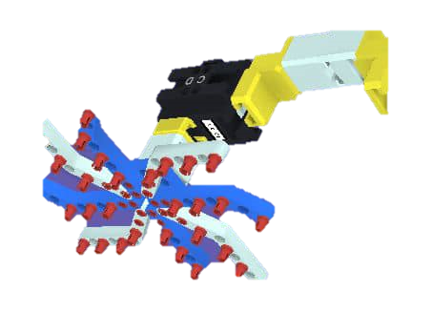
The Sweeper The Carrier without Fender
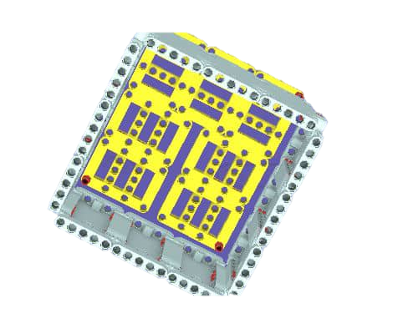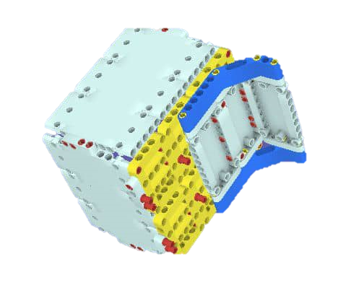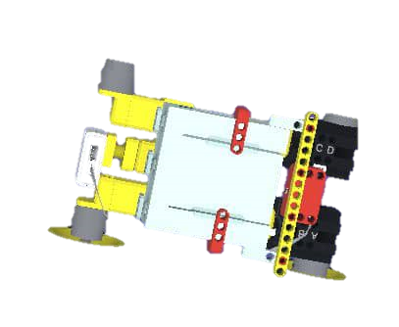
The carrier with Fender The Controller with the Servo Motors

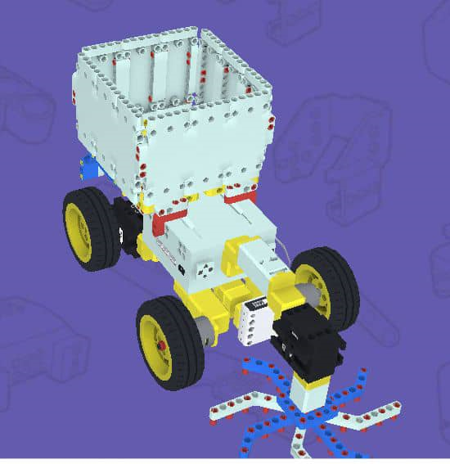
A Robot called the STREET SWEEPER.

